emoji generation based on textual input using generative adversarial networks

DARSHIL AJAY PAREKH

Final Thesis Report

JUNE 2024

DEDICATION

Firstly, I would like to dedicate the master’s thesis project to my parents who have inspired, supported and always encouraged me during the journey. TODO

ACKNOWLEDGEMENTS

I would like to thank and express my gratitude to all those who have contributed to development of this master’s thesis. TODO

ABSTRACT

With the increase in popularity with its wide variety of uses, emojis have become so necessary and important that sending or responding to a message and commenting or reacting to a post on social media without emoji seems to be impossible. Emoji represents emotions, culture, age, gender, actions, gesture, expressions, sports, foods, places and objects.

Despite the importance the number of emojis are countable and finite in quantity. In this research we will be creating a generative model to generate new unique emojis using short text for more complex and distinction emojis

We will be using the state-of-the-art generative models which consist of mainly two-part generator and discriminator. The generator and discriminator will work one after the other. First the generator will be trained to generate new emojis and after couple of rounds the discriminator will be trained to detect is the emoji is fake or real. This is followed by generator and discriminator rounds. This process continues until the discriminator is not able to detect is the emoji is fake.

This will help the community to generate wide variety of emojis based on the requirement rather than choosing from a finite set of emojis.

This research will help to generate high quality and diverse emojis. It will also help the tech community with the comparison of the different GAN models with different evaluation metrics.

**TABLE OF CONTENTS**

DEDICATION 2

ACKNOWLEDGEMENTS 3

ABSTRACT 4

LIST OF FIGURES 8

LIST OF TABLES 9

LIST OF ABBREVIATIONS 10

CHAPTER 1 11

INTRODUCTION 11

1.1 Background of the Study 11

1.2 Problem Statement 13

1.3 Aim and Objectives 13

1.3 Research Questions 14

1.4 Scope of the Study 14

1.5 Significance of the Study 14

1.5.1 Contributions 14

1.5.2 Beneficiaries 14

1.6 Structure of the study 14

CHAPTER 2 15

LITERATURE REVIEW 15

2.1 Introduction 15

2.2 Research on Emoji and its Importance 15

2.3 Research on Emoji Dataset 15

2.4 Research on Emoji Generation 15

2.5 Research on Word Embeddings: 16

2.7 Discussion 18

2.8 Summary 18

CHAPTER 3 19

RESEARCH METHODOLOGY 19

3.1 Research Methodology 19

3.1.1 Introduction 19

3.1.2 Dataset description 19

3.1.3 Data preprocessing 20

3.1.4 Transformation 20

3.1.5 Models 20

3.1.6 High Level Flow Diagram 21

3.1.7 Evaluation metrics 21

CHAPTER 4 22

ANALYSIS 22

4.1 Introduction 22

4.2 Dataset Description 22

4.3 Data Preparation 22

4.3.1 Elimination of Variables 22

4.3.2 Transformation into Categorical Variables 22

4.3.3 Identification of missing values 22

4.3.4 Univariate analysis 22

4.3.5 Treatment of missing values 22

4.3.6 Splitting of original dataset 22

4.4 Exploratory Data Analysis (Bivariate analysis) 22

4.4.1 Chi-square test 22

4.5 Data Visualization 22

4.9 Summary 22

CHAPTER 5 23

RESULTS AND DISCUSSIONS 23

5.1 Introduction 23

5.2 Interpretation of Visualizations 23

5.3 Evaluation of Sampling Methods and Results 23

5.4 Testing on Validation Dataset 23

5.6 Summary 23

CHAPTER 6 24

CONCLUSIONS AND RECOMMENDATIONS 24

6.1 Introduction 24

6.2 Discussion and Conclusion 24

6.3 Contribution to knowledge 24

6.4 Future Recommendations 24

REFERENCES 26

APPENDIX A: RESEARCH PROPOSAL 27

Abstract 29

LIST OF FIGURES 31

LIST OF TABLES 32

LIST OF ABBREVIATIONS 33

1. Background 34

2.1 Problem Statement 36

2.2 Related Work 37

2.2.1 Research on Emoji and its Importance 37

2.2.3 Research on Word Embeddings: 38

3. Research Questions 40

3.1 Research Questions 40

4. Aim and Objectives 40

5. Significance of the Study 41

5.1 Contributions 41

5.2 Beneficiaries 41

6. Scope of the Study 41

7. Research Methodology 42

7.1 Introduction 42

7.2 Dataset description 42

7.3 Data preprocessing 42

7.4 Transformation 43

7.5 Models 43

7.6 High Level Flow Diagram 44

7.7 Evaluation metrics 44

8. Requirements or Resources 45

8.1 Hardware Requirement 45

8.2 Software, Web Services and Libraries Requirement 45

9. Research Plan 46

References 47

APPENDIX B: ETHICS FORMS 48

LIST OF FIGURES

Figure 1 Sample emojis used frequently in informal communication. 10

Figure 2 Emoji used in a feedback form 11

Figure 3 Dataset sample 18

Figure 4 High Level Flow Diagram 20

Figure 5 Research Plan 22

LIST OF TABLES

Table 1 Related works on Methodologies 15

Table 2 State-of-the-art model to be used for emoji generation 20

LIST OF ABBREVIATIONS

GAN Generative Adversarial Network

VQGAN Vector Quantized Generative Adversarial Network

DCGAN Deep Convolution Generative Adversarial Network

CLIP Contrastive Language-Image Pre-Training

AI Artificial Intelligence

ML Machine Learning

RGB Red Green Blue

RGBA Red Green Blue Alpha

CHAPTER 1

INTRODUCTION

1.1 Background of the Study

Emoji is a visual representation of human interaction based on Human emotions, living beings, objects and symbols. These are in widespread use across the internet such as in textual messaging application, social media platforms which are known as informal modes of communication. Below is an image about the most frequently used emojis during informal modes of communication.

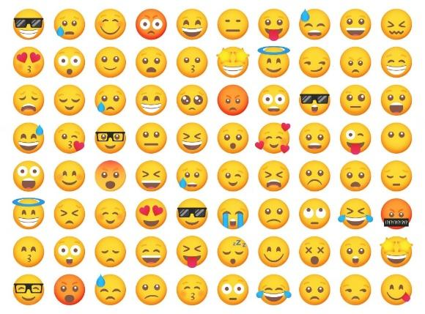

Figure 1 Sample emojis used frequently in informal communication.

According to (Kennison et al., 2024) emojis represent faces with human expressions, objects, animals, and actions.

Emojis are often used to in replacement of words, thus acting as a part of communication and language (Provine et al., 2007). As per the research (Urumutta Hewage et al., 2021) the emojis are static images which are often preserved as human like emotion and expressions. Further, as per (Erle et al., 2022) the communication has greater emotional intensity when we communicated to people using emojis rather than without emojis.

Other application of emojis other than informal communication includes

* Rating/Feedback Form : The feedback forms using emoji instead of stars or numbers. The research has found that the chances of the user giving feedback is higher when emojis are used.
* Providing a Reaction : These days most online applications or websites provide emojis to react to a post, blog, article or tweet.
  + Thumbs up and down emojis are used to like and dislike.
  + Facial emojis are used to express feeling like surprise, wow or shocked.

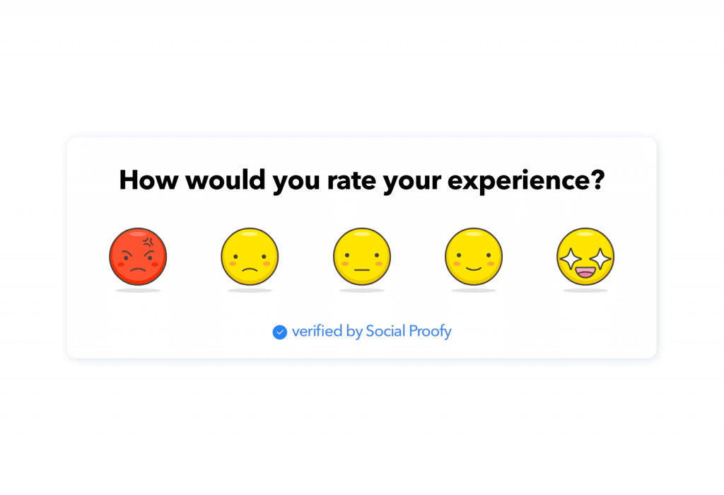

Figure 2 Emoji used in a feedback form

As per the emojipedia.org analysis of over 2.934 billion global tweets between 2017 to 2021, the percentage of tweets with at least one emoji has increased from 13.5% to 21.5%. With the increase of the use of emoji, the demand for newer and customised emoji is increasing. The creation of emoji is a currently is a tedious process of submitting an emoji to Unicode Technical Committee, which takes the final decision for the inclusion, this takes 18-24 months for the complete process Using the state-of-the-art models for generating images using text, we will be able to create new emojis based on the user input.

Prior research has focused on generating facial emojis and emotion based facial emojis. With the state-of-the-art model and architecture, we will be generating not only facial emojis but objects also.

Prior research used techniques like unsupervised learning , Deep Convolution based Generative Adversarial Networks and Conditional Generative Adversarial Networks.

One of the greatest debates on emojis includes whether emoji can be used “as punctuation” or ”after punctuation” which was included in “The Great Emoji Debate”.

In this research we will be creating a state-of-the-art model to generate emojis using emoji content and descriptive information of the emoji and comparing the model with prior models.

We will be looking at the various generative adversarial models :

* VQGAN-CLIP
* TextControl-GAN
* StyleGAN-T

1.2 Problem Statement

Currently the process of creating new emojis is a tedious and time-consuming task which takes a couple of days or months to create and years to get approval from the Unicode Technical Committee. Currently there are only 3,664 emojis as per Unicode standard and the need for need and diverse emoji is increasing. Due to this the current library faces limitations in capturing all the human emotion and experiences. This can lead to miscommunication and inadequate representation of culture and identities.

As per the current trend the use of emoji has been steadily increasing in informal conversation and social media. The need for new emojis to be generated quickly based on the text from the user is high. This issue mostly affects the Gen Z generation as they are the ones who use them mostly during the social media platforms, Messaging apps and content creation. It is important as it can improve the quality of the conversation with improved emotions and objects. This solution will have a huge impact on the conversation by improving the quality of the conversation with new and better emojis which can express emotions and objects accurately.

1.3 Aim and Objectives

The aim of this research is to propose a generative model to generate new emojis is to create a new and diverse design based on textual input from the user and compare it with the baseline and previous models which are visually appealing and useful.

Below are the list of research objectives which will be accomplished in this research:

* To create a generative model that can create new high quality and realistic emojis.
* To generate emoji based on the platform of use.
* To compare between the state-of-the-art generative models.
* To evaluate the performance of the emojis generated using the generative models.
* To finetune the various parameters used in the generative model.

1.3 Research Questions

Generate new realistic emoji in real time based on the textual input from the user.

1.4 Scope of the Study

The scope of a study on generating new emojis are as follows:

* Type of architecture : Generative Adversarial Networks
* Data : <https://huggingface.co/datasets/ChengAoShen/emoji_with_text>
* Input : Short textual input
* Output : 64x64 emoji
* Evaluation techniques :
  + Inception Score (Shmelkov et al., 2018)
  + Fréchet Inception Distance (Shmelkov et al., 2018) (Lee et al., 2023)
  + Learned Perceptual Image Patch Similarity (Lee et al., 2023)
  + Structural Similarity Index (Mittal et al., 2020)

1.5 Significance of the Study

1.5.1 Contributions

* Offer users a wider range of options to accurately express their emotions and experiences using emoji,
* Reflects the variety of individuals and communities.
* Contribute to the development and application of GANs
* Valuable tool for individuals and communities to create custom emojis

1.5.2 Beneficiaries

* Users of social media platforms.
* Content creators like article and blog writers.
* The AI and ML industry.
* Emoji Designers.
* Unicode and emoji organisations like emojipedia.

1.6 Structure of the study

CHAPTER 2

LITERATURE REVIEW

2.1 Introduction

GAN or Generative Adversarial Networks belong to generative model family. This model helps to generate new samples from the same distribution from similar sample dataset. Over the last decade, there is significant progress in GAN models. In this chapter we will study the various types of research on GAN and its applications, importance of emoji, various datasets, types and advantages of word embeddings and comparison of various metrics used to test different models.

2.2 GAN Types and Applications

2.2.1 Basic GAN

In 2014 Ian Goodfellow and his colleagues developed the basic GAN model. It was based on zero sum and min max game theory. Here's a simplified explanation of GANs:

* The Forger (Generator): A computer program that starts by making very bad drawings   
  of the emoji
* The Detective (Discriminator): Another computer program that gets shown both real emoji and the Forger's fakes. The Detective tries to tell them apart.

Each time the Detective catches a fake, the Forger learns from its mistakes and tries to make even better fakes. This makes the Detective have to get smarter too.

2.2 Research on Emoji and its Importance

Emoji despite being more common in digital communication, is often dependent on characteristics, motives for using them and the context in which they are used (Cavalheiro et al., 2023). Over the past couple of years there has been extensive research in the use and importance of emojis in every life activity. Below are few of the recent research with description and findings:

* The research by (Cavalheiro et al., 2023) try to find the relationship of frequency of the emoji with relationship and individual characteristics. The research also found personal reasons to be one of the relates to high emoji frequency. The research also found age to be directly correlated with emoji frequency which was unexpected.
* The research by (Erle et al., 2022) discusses a creation of emojis in digital communication with the help of their model. The research also found that the emojis can depict the facial expression of the human.
* The research by (Lefebvre et al., 2024) is about the influence of emoji during tip suggestion with the tipping percentage. The research also found significant positive effects of emoji during the tipping.
* The research by (Kennison et al., 2024) relates the personal characteristics with the emojis used in the conversation. The research also found that the men used emojis less often than women. The research also found that users may me using emojis in place of word and used less dictionary words.

2.3 Research on Emoji Dataset

2.4 Research on Emoji Generation

With the evolution generative models and the importance of emoji there has been couple of research done in the field of emoji generation. It has been noticed that most of the research has been around facial emojis and with a very limited set of them. Below are few of the recent research with description:

* The research (Mittal et al., 2020) uses supervised learning with multimodal input to GAN with U-Net like architecture for the generator to generate realistic hand drawn emojis. This research even though was able to generate the emojis it required the user to draw a rough sketch with the emotion to be given as input, also the dataset used had to be augmented from the facial emojis which don’t depict the real dataset.
* The research (Lee et al., 2023) creates a model which can generate emojis based on emotional degree for more complex and detailed usage on online conversations (Lee et al., 2023). The research uses conditional GAN for the experiment and also compares it with other baseline models. This
* The research (Tang, 2023) used unsupervised learning to generate new emojis using DCGAN which is a combination of Convolution Neural Network and Generative Adversarial Network. This research faced many challenges like after 1000 epochs the accuracy flattens out. The emojis generated where quite blurry and the user had no control over the emojis generated due to unsupervised learning.
* The research (Xu, 2021) used unsupervised learning with optimization techniques with Adam Optimizer to generate new emojis.
* The research (Peng and Zhao, 2021) used an encoder–decoder model, to predict the sequence of emojis based on short text. This research was able to correlate the emojis generated. The model was also able to learn the semantics between the emoji and text description.

Although the above research where able to generate emojis but most of this research had sparse data and limited the scope to generate facial emojis.

2.5 Research on Word Embeddings:

According to the research by (Asudani et al., 2023) the first preference should be given to domain specific embeddings. The research also compares the performance of the various word embedding techniques.

**2.6 Research on Text to Image Generation Methodology**

Below are the recent methodologies in the text to image domain developed on top of generative adversarial network architecture.

|  |  |  |
| --- | --- | --- |
| **Methodology** | **Use** | **Description** |
| **Attn-GAN** (Xu et al., 2018) | Text to Image Generation | The research proposes a new GAN with multistage refinement using attention. Each of this multistage attention model gets the most relevant word vectors for generating sub-regions of the image (Xu et al., 2018). |
| **Stack-GAN** (Dhivya and Navas, 2020) | Image Generation based on text | The research proposes the use of multiple GAN stacked on top of each other to generate high resolution photo realistic images (Trevisan de Souza et al., 2023). |
| **Style-CLIP**(Patashnik et al., 2021) | Text-guided image editing | This research proposes CLIP embeddings to allow image editing. The CLIP embeddings share the same latent space hence we can directly compare the text with the images (Trevisan de Souza et al., 2023). |
| **VQGAN-CLIP**(Crowson et al., 2022) | Text-to-image synthesis | This research proposes a model where an encoder is used to create a latent vector which is used by the decoder to create the image. It also uses CLIP embedding with optimization techniques to have high similarity with the text prompt. (Trevisan de Souza et al., 2023). |
| **TextControl-GAN** (Ku and Lee, 2023) | Text to Image | The research proposes a neural network as regressor to learn the textual features. The research also uses data augmentation techniques to increase the performance(Ku and Lee, 2023). |
| **StyleGAN-T**(Sauer et al., 2023) | Text-to-image synthesis | This research proposes a model build from Style GAN-XL mentioned before. The network size of the model is increased to include text information from CLIP encoders.  (Trevisan de Souza et al., 2023). |

Table 1 Related works on Methodologies

2.7 Discussion

2.8 Summary

CHAPTER 3

RESEARCH METHODOLOGY

3.1 Research Methodology

In this chapter we will be going through the end-to-end architecture which included data preprocessing, data transformation, the state-of-the-art methodology and the evaluation metrics used in the research.

3.1.1 Introduction

Here's a simplified explanation of GANs:

* The Forger (Generator): A computer program that starts by making very bad drawings   
  of the emoji
* The Detective (Discriminator): Another computer program that gets shown both real emoji and the Forger's fakes. The Detective tries to tell them apart.

Each time the Detective catches a fake, the Forger learns from its mistakes and tries to make even better fakes. This makes the Detective have to get smarter too.

3.1.2 Dataset description

The dataset (ChengAo Shen and Siyuan Mu, 2023) is uploaded on Hugging face. This dataset consists of 47200 emojis with the text description. Each image is of shape 64*64 and has RGBA channels. Description text format : app or company, emoji content, description information

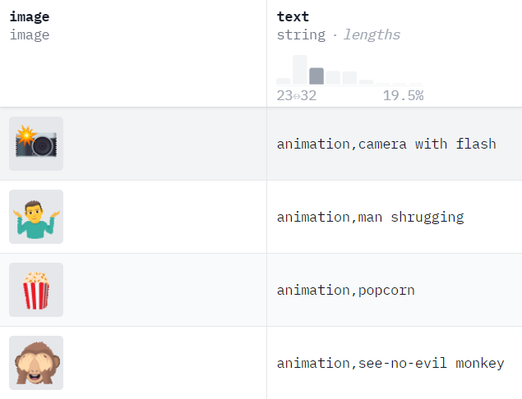

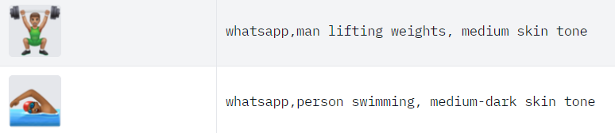 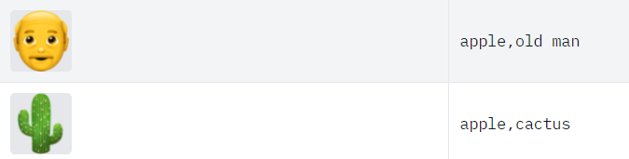

Figure 3 Dataset sample

3.1.3 Data preprocessing

The dataset doesn't require any cleaning or filtering as it has already been done by the author of the dataset. All the emoji are of the shape 64x64x4 where 4 is the number of channels which represent RGBA (Red, Green, Blue, Alpha) which can be converted to RGB(Red, Green, Blue) format. The text description will be split into 3 columns: app/company, emoji content, description information using regular expressions. These 3 columns will be processed to remove stop word and name entity recognition will be used to identify the company and keywords from the description. The dataset will be organised and divided into 3 parts for training, testing and validation.

3.1.4 Transformation

* Latent Space Manipulation  
  Latent space is the hidden layers in the architecture which can be seen as compressed input. As proposed in (Yang et al., 2021) we can use latent space factorization or manipulations to change the attributes of the image.
* Word to Vector  
  The text description for the emojis will be converted to vector representation.  
  They capture the meaning and their usage.
* Clip embedding

The images and text vectors share the same latent space which is helpful in direct comparison of the both

3.1.5 Models

Below are the recent shortlisted state of the art model which we will be using and comparing to generate the emojis using the textual input.

|  |  |
| --- | --- |
| **Methodology** | **Description** |
| **VQGAN-CLIP** (Crowson et al., 2022) | This research proposes a model where an encoder is used to create a latent vector which is used by the decoder to create the image. It also uses CLIP embedding with optimization techniques to have high similarity with the text prompt. (Trevisan de Souza et al., 2023). |
| **TextControl-GAN** (Ku and Lee, 2023) | The research proposes a neural network as regressor to learn the textual features. The research also uses data augmentation techniques to increase the performance(Ku and Lee, 2023). |
| **StyleGAN-T** (Sauer et al., 2023) | This research proposes a model build from Style GAN-XL mentioned before. The network size of the model is increased to include text information from CLIP encoders.  (Trevisan de Souza et al., 2023). |

Table 2 State-of-the-art model to be used for emoji generation

3.1.6 High Level Flow Diagram

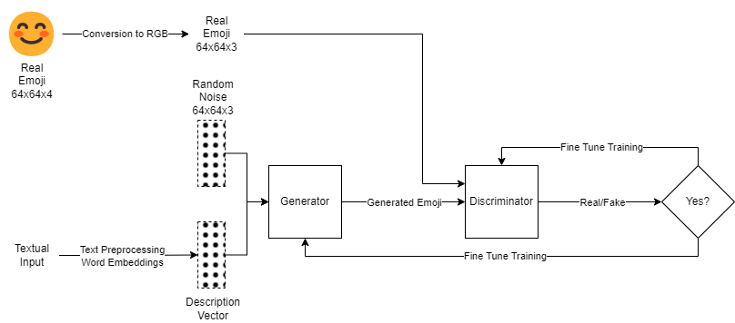

Figure 4 High Level Flow Diagram

3.1.7 Evaluation metrics

We can measure the image quality the following metrics are used

* Inception Score (Shmelkov et al., 2018)   
  It is used to measure the quality of the images generated by comparing it with the real images from the dataset.
* Fréchet Inception Distance (Shmelkov et al., 2018) (Lee et al., 2023)

It is the measure to check how real the image generated are.

* Learned Perceptual Image Patch Similarity (Lee et al., 2023)

It is the distance measured between the patches in the latent space.

* Structural Similarity Index (Mittal et al., 2020)

It measures the degradation of the image quality

CHAPTER 4

ANALYSIS

4.1 Introduction

4.2 Dataset Description

4.3 Data Preparation

4.3.1 Elimination of Variables

4.3.2 Transformation into Categorical Variables

4.3.3 Identification of missing values

4.3.4 Univariate analysis

4.3.5 Treatment of missing values

4.3.6 Splitting of original dataset

4.4 Exploratory Data Analysis (Bivariate analysis)

4.4.1 Chi-square test

4.5 Data Visualization

4.9 Summary

CHAPTER 5

RESULTS AND DISCUSSIONS

5.1 Introduction

5.2 Interpretation of Visualizations

5.3 Evaluation of Sampling Methods and Results

5.4 Testing on Validation Dataset

5.6 Summary

CHAPTER 6

CONCLUSIONS AND RECOMMENDATIONS

6.1 Introduction

6.2 Discussion and Conclusion

6.3 Contribution to knowledge

6.4 Future Recommendations

REFERENCES

Asudani, D.S., Nagwani, N.K. and Singh, P., (2023) Impact of word embedding models on text analytics in deep learning environment: a review. *Artificial Intelligence Review*, [online] 569, pp.10345–10425. Available at: https://doi.org/10.1007/s10462-023-10419-1.

Cavalheiro, B.P., Rodrigues, D.L. and Prada, M., (2023) Who (and with whom) uses more emoji? Exploring individual, relational, and motivational characteristics driving emoji use. *Telematics and Informatics*, [online] 83, p.102023. Available at: https://www.sciencedirect.com/science/article/pii/S0736585323000874.

Crowson, K., Biderman, S., Kornis, D., Stander, D., Hallahan, E., Castricato, L. and Raff, E., (2022) Vqgan-clip: Open domain image generation and editing with natural language guidance. In: *European Conference on Computer Vision*. Springer, pp.88–105.

Dhivya, K. and Navas, N.S., (2020) Text to realistic image generation using stackgan. In: *2020 7th International Conference on Smart Structures and Systems (ICSSS)*. IEEE, pp.1–7.

Erle, T.M., Schmid, K., Goslar, S.H. and Martin, J.D., (2022) Emojis as social information in digital communication. *Emotion*, 227, p.1529.

Kennison, S.M., Fritz, K., Morales, M.A.H. and Chan-Tin, E., (2024) Emoji use in social media posts: relationships with personality traits and word usage. *Frontiers in Psychology*, 15.

Ku, H. and Lee, M., (2023) TextControlGAN: Text-to-Image Synthesis with Controllable Generative Adversarial Networks. *Applied Sciences*, 138, p.5098.

Lee, S., Kim, S., Chu, Y., Choi, J., Park, E. and Woo, S.S., (2023) EAE-GAN: Emotion-Aware Emoji Generative Adversarial Network for Computational Modeling Diverse and Fine-Grained Human Emotions. *IEEE Transactions on Computational Social Systems*, pp.1–11.

Mittal, P., Aggarwal, K., Sahu, P.P., Vatsalya, V., Mitra, S., Singh, V., Veera, V. and Venkatesan, S.M., (2020) Photo-realistic emoticon generation using multi-modal input. In: *Proceedings of the 25th International Conference on Intelligent User Interfaces*. pp.254–258.

Patashnik, O., Wu, Z., Shechtman, E., Cohen-Or, D. and Lischinski, D., (2021) Styleclip: Text-driven manipulation of stylegan imagery. In: *Proceedings of the IEEE/CVF International Conference on Computer Vision*. pp.2085–2094.

Provine, R.R., Spencer, R.J. and Mandell, D.L., (2007) Emotional expression online: Emoticons punctuate website text messages. *Journal of language and social psychology*, 263, pp.299–307.

Sauer, A., Karras, T., Laine, S., Geiger, A. and Aila, T., (2023) Stylegan-t: Unlocking the power of gans for fast large-scale text-to-image synthesis. *arXiv preprint arXiv:2301.09515*.

Shmelkov, K., Schmid, C. and Alahari, K., (2018) How good is my GAN? In: *Proceedings of the European conference on computer vision (ECCV)*. pp.213–229.

Trevisan de Souza, V.L., Marques, B.A.D., Batagelo, H.C. and Gois, J.P., (2023) A review on Generative Adversarial Networks for image generation. *Computers & Graphics*, [online] 114, pp.13–25. Available at: https://www.sciencedirect.com/science/article/pii/S009784932300064X.

Urumutta Hewage, G.S., Liu, Y., Wang, Z. and Mao, H., (2021) Consumer responses toward symmetric versus asymmetric facial expression emojis. *Marketing Letters*, 32, pp.219–230.

Xu, T., Zhang, P., Huang, Q., Zhang, H., Gan, Z., Huang, X. and He, X., (2018) Attngan: Fine-grained text to image generation with attentional generative adversarial networks. In: *Proceedings of the IEEE conference on computer vision and pattern recognition*. pp.1316–1324.

APPENDIX A: RESEARCH PROPOSAL

emoji generation based on textual input using generative adversarial networks

DARSHIL AJAY PAREKH

Research Proposal

FEBRUARY 2024

Abstract

With the increase in popularity with its wide variety of uses, emojis have become so necessary and important that sending or responding to a message and commenting or reacting to a post on social media without emoji seems to be impossible. Emoji represents emotions, culture, age, gender, actions, gesture, expressions, sports, foods, places and objects.

Despite the importance the number of emojis are countable and finite in quantity. In this research we will be creating a generative model to generate new unique emojis using short text for more complex and distinction emojis

We will be using the state-of-the-art generative models which consist of mainly two-part generator and discriminator. The generator and discriminator will work one after the other. First the generator will be trained to generate new emojis and after couple of rounds the discriminator will be trained to detect is the emoji is fake or real. This is followed by generator and discriminator rounds. This process continues until the discriminator is not able to detect is the emoji is fake.

This will help the community to generate wide variety of emojis based on the requirement rather than choosing from a finite set of emojis.

This research will help to generate high quality and diverse emojis. It will also help the tech community with the comparison of the different GAN models with different evaluation metrics.

**TABLE OF CONTENTS**

Abstract 2

LIST OF FIGURES 4

LIST OF TABLES 5

LIST OF ABBREVIATIONS 6

1. Background 7

2.1 Problem Statement 9

2.2 Related Work 10

2.2.1 Research on Emoji and its Importance 10

2.2.3 Research on Word Embeddings: 11

3. Research Questions 13

3.1 Research Questions 13

4. Aim and Objectives 13

5. Significance of the Study 14

5.1 Contributions 14

5.2 Beneficiaries 14

6. Scope of the Study 14

7. Research Methodology 15

7.1 Introduction 15

7.2 Dataset description 15

7.3 Data preprocessing 16

7.4 Transformation 16

7.5 Models 16

7.6 High Level Flow Diagram 17

7.7 Evaluation metrics 17

8. Requirements or Resources 18

8.1 Hardware Requirement 18

8.2 Software, Web Services and Libraries Requirement 18

9. Research Plan 19

LIST OF FIGURES

Figure 1 Sample emojis used frequently in informal communication. 7

Figure 2 Emoji used in a feedback form 8

Figure 3 Dataset sample 15

Figure 4 High Level Flow Diagram 17

Figure 5 Research Plan 19

LIST OF TABLES

Table 1 Related works on Methodologies 12

Table 2 State-of-the-art model to be used for emoji generation 17

LIST OF ABBREVIATIONS

GAN Generative Adversarial Network

VQGAN Vector Quantized Generative Adversarial Network

DCGAN Deep Convolution Generative Adversarial Network

CLIP Contrastive Language-Image Pre-Training

AI Artificial Intelligence

ML Machine Learning

RGB Red Green Blue

RGBA Red Green Blue Alpha

1. Background

Emoji is a visual representation of human interaction based on Human emotions, living beings, objects and symbols. These are in widespread use across the internet such as in textual messaging application, social media platforms which are known as informal modes of communication. Below is an image about the most frequently used emojis during informal modes of communication.



Figure 1 Sample emojis used frequently in informal communication.

According to (Kennison et al., 2024) emojis represent faces with human expressions, objects, animals, and actions.

Emojis are often used to in replacement of words, thus acting as a part of communication and language (Provine et al., 2007). As per the research (Urumutta Hewage et al., 2021) the emojis are static images which are often preserved as human like emotion and expressions. Further, as per (Erle et al., 2022) the communication has greater emotional intensity when we communicated to people using emojis rather than without emojis.

Other application of emojis other than informal communication includes

* Rating/Feedback Form : The feedback forms using emoji instead of stars or numbers. The research has found that the chances of the user giving feedback is higher when emojis are used.
* Providing a Reaction : These days most online applications or websites provide emojis to react to a post, blog, article or tweet.
  + Thumbs up and down emojis are used to like and dislike.
  + Facial emojis are used to express feeling like surprise, wow or shocked.



Figure 2 Emoji used in a feedback form

As per the emojipedia.org analysis of over 2.934 billion global tweets between 2017 to 2021, the percentage of tweets with at least one emoji has increased from 13.5% to 21.5%. With the increase of the use of emoji, the demand for newer and customised emoji is increasing. The creation of emoji is a currently is a tedious process of submitting an emoji to Unicode Technical Committee, which takes the final decision for the inclusion, this takes 18-24 months for the complete process Using the state-of-the-art models for generating images using text, we will be able to create new emojis based on the user input.

Prior research has focused on generating facial emojis and emotion based facial emojis. With the state-of-the-art model and architecture, we will be generating not only facial emojis but objects also.

Prior research used techniques like unsupervised learning , Deep Convolution based Generative Adversarial Networks and Conditional Generative Adversarial Networks.

One of the greatest debates on emojis includes whether emoji can be used “as punctuation” or ”after punctuation” which was included in “The Great Emoji Debate”.

In this research we will be creating a state-of-the-art model to generate emojis using emoji content and descriptive information of the emoji and comparing the model with prior models.

We will be looking at the various generative adversarial models :

* VQGAN-CLIP
* TextControl-GAN
* StyleGAN-T

**2. Problem Statement and Related Work**

2.1 Problem Statement

Currently the process of creating new emojis is a tedious and time-consuming task which takes a couple of days or months to create and years to get approval from the Unicode Technical Committee. Currently there are only 3,664 emojis as per Unicode standard and the need for need and diverse emoji is increasing. Due to this the current library faces limitations in capturing all the human emotion and experiences. This can lead to miscommunication and inadequate representation of culture and identities.

As per the current trend the use of emoji has been steadily increasing in informal conversation and social media. The need for new emojis to be generated quickly based on the text from the user is high. This issue mostly affects the Gen Z generation as they are the ones who use them mostly during the social media platforms, Messaging apps and content creation. It is important as it can improve the quality of the conversation with improved emotions and objects. This solution will have a huge impact on the conversation by improving the quality of the conversation with new and better emojis which can express emotions and objects accurately.

2.2 Related Work

2.2.1 Research on Emoji and its Importance

Emoji despite being more common in digital communication, is often dependent on characteristics, motives for using them and the context in which they are used (Cavalheiro et al., 2023). Over the past couple of years there has been extensive research in the use and importance of emojis in every life activity. Below are few of the recent research with description and findings:

* The research by (Cavalheiro et al., 2023) try to find the relationship of frequency of the emoji with relationship and individual characteristics. The research also found personal reasons to be one of the relates to high emoji frequency. The research also found age to be directly correlated with emoji frequency which was unexpected.
* The research by (Erle et al., 2022) discusses a creation of emojis in digital communication with the help of their model. The research also found that the emojis can depict the facial expression of the human.
* The research by (Lefebvre et al., 2024) is about the influence of emoji during tip suggestion with the tipping percentage. The research also found significant positive effects of emoji during the tipping.
* The research by (Kennison et al., 2024) relates the personal characteristics with the emojis used in the conversation. The research also found that the men used emojis less often than women. The research also found that users may me using emojis in place of word and used less dictionary words.

**2.2.2 Research on Emoji Generation**

With the evolution generative models and the importance of emoji there has been couple of research done in the field of emoji generation. It has been noticed that most of the research has been around facial emojis and with a very limited set of them. Below are few of the recent research with description:

* The research (Mittal et al., 2020) uses supervised learning with multimodal input to GAN with U-Net like architecture for the generator to generate realistic hand drawn emojis. This research even though was able to generate the emojis it required the user to draw a rough sketch with the emotion to be given as input, also the dataset used had to be augmented from the facial emojis which don’t depict the real dataset.
* The research (Lee et al., 2023) creates a model which can generate emojis based on emotional degree for more complex and detailed usage on online conversations (Lee et al., 2023). The research uses conditional GAN for the experiment and also compares it with other baseline models. This
* The research (Tang, 2023) used unsupervised learning to generate new emojis using DCGAN which is a combination of Convolution Neural Network and Generative Adversarial Network. This research faced many challenges like after 1000 epochs the accuracy flattens out. The emojis generated where quite blurry and the user had no control over the emojis generated due to unsupervised learning.
* The research (Xu, 2021) used unsupervised learning with optimization techniques with Adam Optimizer to generate new emojis.
* The research (Peng and Zhao, 2021) used an encoder–decoder model, to predict the sequence of emojis based on short text. This research was able to correlate the emojis generated. The model was also able to learn the semantics between the emoji and text description.

Although the above research where able to generate emojis but most of this research had sparse data and limited the scope to generate facial emojis.

2.2.3 Research on Word Embeddings:

According to the research by (Asudani et al., 2023) the first preference should be given to domain specific embeddings. The research also compares the performance of the various word embedding techniques.

**2.2.4 Research on Text to Image Generation Methodology**

Below are the recent methodologies in the text to image domain developed on top of generative adversarial network architecture.

|  |  |  |
| --- | --- | --- |
| **Methodology** | **Use** | **Description** |
| **Attn-GAN** (Xu et al., 2018) | Text to Image Generation | The research proposes a new GAN with multistage refinement using attention. Each of this multistage attention model gets the most relevant word vectors for generating sub-regions of the image (Xu et al., 2018). |
| **Stack-GAN** (Dhivya and Navas, 2020) | Image Generation based on text | The research proposes the use of multiple GAN stacked on top of each other to generate high resolution photo realistic images (Trevisan de Souza et al., 2023). |
| **Style-CLIP**(Patashnik et al., 2021) | Text-guided image editing | This research proposes CLIP embeddings to allow image editing. The CLIP embeddings share the same latent space hence we can directly compare the text with the images (Trevisan de Souza et al., 2023). |
| **VQGAN-CLIP**(Crowson et al., 2022) | Text-to-image synthesis | This research proposes a model where an encoder is used to create a latent vector which is used by the decoder to create the image. It also uses CLIP embedding with optimization techniques to have high similarity with the text prompt. (Trevisan de Souza et al., 2023). |
| **TextControl-GAN** (Ku and Lee, 2023) | Text to Image | The research proposes a neural network as regressor to learn the textual features. The research also uses data augmentation techniques to increase the performance(Ku and Lee, 2023). |
| **StyleGAN-T**(Sauer et al., 2023) | Text-to-image synthesis | This research proposes a model build from Style GAN-XL mentioned before. The network size of the model is increased to include text information from CLIP encoders.  (Trevisan de Souza et al., 2023). |

Table 1 Related works on Methodologies

3. Research Questions

3.1 Research Questions

Generate new realistic emoji in real time based on the textual input from the user.

4. Aim and Objectives

The aim of this research is to propose a generative model to generate new emojis is to create a new and diverse design based on textual input from the user and compare it with the baseline and previous models which are visually appealing and useful.

Below are the list of research objectives which will be accomplished in this research:

* To create a generative model that can create new high quality and realistic emojis.
* To generate emoji based on the platform of use.
* To compare between the state-of-the-art generative models.
* To evaluate the performance of the emojis generated using the generative models.
* To finetune the various parameters used in the generative model.

5. Significance of the Study

5.1 Contributions

* Offer users a wider range of options to accurately express their emotions and experiences using emoji,
* Reflects the variety of individuals and communities.
* Contribute to the development and application of GANs
* Valuable tool for individuals and communities to create custom emojis

5.2 Beneficiaries

* Users of social media platforms.
* Content creators like article and blog writers.
* The AI and ML industry.
* Emoji Designers.
* Unicode and emoji organisations like emojipedia.

6. Scope of the Study

The scope of a study on generating new emojis are as follows:

* Type of architecture : Generative Adversarial Networks
* Data : <https://huggingface.co/datasets/ChengAoShen/emoji_with_text>
* Input : Short textual input
* Output : 64x64 emoji
* Evaluation techniques :
  + Inception Score (Shmelkov et al., 2018)
  + Fréchet Inception Distance (Shmelkov et al., 2018) (Lee et al., 2023)
  + Learned Perceptual Image Patch Similarity (Lee et al., 2023)
  + Structural Similarity Index (Mittal et al., 2020)

7. Research Methodology

In this section we will be going through the end-to-end architecture which included data preprocessing, data transformation, the state-of-the-art methodology and the evaluation metrics used in the research.

7.1 Introduction

Here's a simplified explanation of GANs:

* The Forger (Generator): A computer program that starts by making very bad drawings   
  of the emoji
* The Detective (Discriminator): Another computer program that gets shown both real emoji and the Forger's fakes. The Detective tries to tell them apart.

Each time the Detective catches a fake, the Forger learns from its mistakes and tries to make even better fakes. This makes the Detective have to get smarter too.

7.2 Dataset description

The dataset (ChengAo Shen and Siyuan Mu, 2023) is uploaded on Hugging face. This dataset consists of 47200 emojis with the text description. Each image is of shape 64*64 and has RGBA channels. Description text format : app or company, emoji content, description information



 

Figure 3 Dataset sample

7.3 Data preprocessing

The dataset doesn't require any cleaning or filtering as it has already been done by the author of the dataset. All the emoji are of the shape 64x64x4 where 4 is the number of channels which represent RGBA (Red, Green, Blue, Alpha) which can be converted to RGB(Red, Green, Blue) format. The text description will be split into 3 columns: app/company, emoji content, description information using regular expressions. These 3 columns will be processed to remove stop word and name entity recognition will be used to identify the company and keywords from the description. The dataset will be organised and divided into 3 parts for training, testing and validation.

7.4 Transformation

* Latent Space Manipulation  
  Latent space is the hidden layers in the architecture which can be seen as compressed input. As proposed in (Yang et al., 2021) we can use latent space factorization or manipulations to change the attributes of the image.
* Word to Vector  
  The text description for the emojis will be converted to vector representation.  
  They capture the meaning and their usage.
* Clip embedding

The images and text vectors share the same latent space which is helpful in direct comparison of the both

7.5 Models

Below are the recent shortlisted state of the art model which we will be using and comparing to generate the emojis using the textual input.

|  |  |
| --- | --- |
| **Methodology** | **Description** |
| **VQGAN-CLIP** (Crowson et al., 2022) | This research proposes a model where an encoder is used to create a latent vector which is used by the decoder to create the image. It also uses CLIP embedding with optimization techniques to have high similarity with the text prompt. (Trevisan de Souza et al., 2023). |
| **TextControl-GAN** (Ku and Lee, 2023) | The research proposes a neural network as regressor to learn the textual features. The research also uses data augmentation techniques to increase the performance(Ku and Lee, 2023). |
| **StyleGAN-T** (Sauer et al., 2023) | This research proposes a model build from Style GAN-XL mentioned before. The network size of the model is increased to include text information from CLIP encoders.  (Trevisan de Souza et al., 2023). |

Table 2 State-of-the-art model to be used for emoji generation

7.6 High Level Flow Diagram



Figure 4 High Level Flow Diagram

7.7 Evaluation metrics

We can measure the image quality the following metrics are used

* Inception Score (Shmelkov et al., 2018)   
  It is used to measure the quality of the images generated by comparing it with the real images from the dataset.
* Fréchet Inception Distance (Shmelkov et al., 2018) (Lee et al., 2023)

It is the measure to check how real the image generated are.

* Learned Perceptual Image Patch Similarity (Lee et al., 2023)

It is the distance measured between the patches in the latent space.

* Structural Similarity Index (Mittal et al., 2020)

It measures the degradation of the image quality

8. Requirements or Resources

Initially the data preprocessing, analysis, model creation and partial training will be done on local laptops and for the final training of the complete dataset and validation will be done on cloud VMs

8.1 Hardware Requirement

* Intel i7 processor
* 16gb RAM
* 4gb Video RAM/GPU
* 1 cloud VM with 1 Nvidia A100 GPU

8.2 Software, Web Services and Libraries Requirement

Below are the list of software requirements

* Python 3.12.2
* JupyterLab
* Microsoft Azure/GCP
* PyTorch
* Numpy
* Pandas
* Scikit-learn
* Tensorflow
* Keras
* Matplotlib

9. Research Plan



Figure 5 Research Plan

References

1. Asudani, D.S., Nagwani, N.K. and Singh, P., (2023) Impact of word embedding models on text analytics in deep learning environment: a review. *Artificial Intelligence Review*, [online] 569, pp.10345–10425. Available at: https://doi.org/10.1007/s10462-023-10419-1.
2. Cavalheiro, B.P., Rodrigues, D.L. and Prada, M., (2023) Who (and with whom) uses more emoji? Exploring individual, relational, and motivational characteristics driving emoji use. *Telematics and Informatics*, [online] 83, p.102023. Available at: https://www.sciencedirect.com/science/article/pii/S0736585323000874.
3. Crowson, K., Biderman, S., Kornis, D., Stander, D., Hallahan, E., Castricato, L. and Raff, E., (2022) Vqgan-clip: Open domain image generation and editing with natural language guidance. In: *European Conference on Computer Vision*. Springer, pp.88–105.
4. Dhivya, K. and Navas, N.S., (2020) Text to realistic image generation using stackgan. In: *2020 7th International Conference on Smart Structures and Systems (ICSSS)*. IEEE, pp.1–7.
5. Erle, T.M., Schmid, K., Goslar, S.H. and Martin, J.D., (2022) Emojis as social information in digital communication. *Emotion*, 227, p.1529.
6. Kennison, S.M., Fritz, K., Morales, M.A.H. and Chan-Tin, E., (2024) Emoji use in social media posts: relationships with personality traits and word usage. *Frontiers in Psychology*, 15.
7. Ku, H. and Lee, M., (2023) TextControlGAN: Text-to-Image Synthesis with Controllable Generative Adversarial Networks. *Applied Sciences*, 138, p.5098.
8. Lee, S., Kim, S., Chu, Y., Choi, J., Park, E. and Woo, S.S., (2023) EAE-GAN: Emotion-Aware Emoji Generative Adversarial Network for Computational Modeling Diverse and Fine-Grained Human Emotions. *IEEE Transactions on Computational Social Systems*, pp.1–11.
9. Mittal, P., Aggarwal, K., Sahu, P.P., Vatsalya, V., Mitra, S., Singh, V., Veera, V. and Venkatesan, S.M., (2020) Photo-realistic emoticon generation using multi-modal input. In: *Proceedings of the 25th International Conference on Intelligent User Interfaces*. pp.254–258.
10. Patashnik, O., Wu, Z., Shechtman, E., Cohen-Or, D. and Lischinski, D., (2021) Styleclip: Text-driven manipulation of stylegan imagery. In: *Proceedings of the IEEE/CVF International Conference on Computer Vision*. pp.2085–2094.
11. Provine, R.R., Spencer, R.J. and Mandell, D.L., (2007) Emotional expression online: Emoticons punctuate website text messages. *Journal of language and social psychology*, 263, pp.299–307.
12. Sauer, A., Karras, T., Laine, S., Geiger, A. and Aila, T., (2023) Stylegan-t: Unlocking the power of gans for fast large-scale text-to-image synthesis. *arXiv preprint arXiv:2301.09515*.
13. Shmelkov, K., Schmid, C. and Alahari, K., (2018) How good is my GAN? In: *Proceedings of the European conference on computer vision (ECCV)*. pp.213–229.
14. Trevisan de Souza, V.L., Marques, B.A.D., Batagelo, H.C. and Gois, J.P., (2023) A review on Generative Adversarial Networks for image generation. *Computers & Graphics*, [online] 114, pp.13–25. Available at: https://www.sciencedirect.com/science/article/pii/S009784932300064X.
15. Urumutta Hewage, G.S., Liu, Y., Wang, Z. and Mao, H., (2021) Consumer responses toward symmetric versus asymmetric facial expression emojis. *Marketing Letters*, 32, pp.219–230.
16. Xu, T., Zhang, P., Huang, Q., Zhang, H., Gan, Z., Huang, X. and He, X., (2018) Attngan: Fine-grained text to image generation with attentional generative adversarial networks. In: *Proceedings of the IEEE conference on computer vision and pattern recognition*. pp.1316–1324.